Project No Egypt

# Game Design Document

## Pip Fox, Kamil Stroinski, Kai Barson, Cormac

Concept

# Genre

3D Puzzle platformer.

# Key features

You roll a ball through a temple, trying to get to the bottom floor. You go through the temple using the environment along with different elements to solve puzzles. For example, using the fire ball to burn through a wooden wall.

# Platform / target hardware

PC

# Summary of Story

The main character (the ball’s soul) is trying to escape from Mictlan (Aztec underworld).

When the main character died, the gods thought it was so funny that they decided to give him another chance to live, if he can escape from the Aztec temple.

# Setting

Aztec temple in the underworld (Mictlan).

# Art style

Low-res, pixel art, voxel models

Specification

# Mechanics

* Rolling ball – Use WASD to roll the ball around.
* Changing elements – Roll the ball over a special spot on the floor to change the ball’s material.
* Environmental puzzle – The temple will be filled with different obstacles you pass using a certain material.
  + Ice bridges – Can only be crossed if not using the fire ball
  + Cobweb / wood walls – Can only be passed using the fire ball
  + Bouncing puzzles using rubber ball – You can only bounce using the rubber ball
  + Pools of water, use ice to cross – Only passable using the ice ball to freeze and make a bridge

# User Interface

* Element status icon
* Death counter

# Assets

3D models:

* Ball
* Vases
* Torches

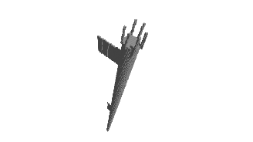

* Spikes
* Cobwebs
* Column
* Ball changer

Sounds / music:

* Ball rolling (all materials)
* Hitting wall
* Gameplay music
* Menu music
* Credits music

Materials:

* Wall & floor
* Ball (4 materials)
* Ice
* Spikes

# Story and characters

The Ball, trying to escape the temple.

When the main character (Orion Cristian) died, the lord of Mictlan (Mictlantecuhtli) thought it was so funny that they decided to give him another chance to live, if he can escape from the Aztec temple.